**Learning About Government**  
**Objective**: to acquaint ourselves with how the Government of Canada is structured; how the country's laws are created; and how the different branches operate.

**The Westminster Parliamentary System Explained**  
Canada's parliamentary system is modelled after that of England's: there are three branches; each is designed to place limits upon the other two. Limitations serve to establish a society governed through the rule of law, i.e. law places necessary constraints on both individual and institutional behavior whereby all members of society (including the government) are equally subject to the law. The three branches are the legislative branch, executive branch and judicial branch. All branches are equally powerful, equally limited, equally important, but perform different roles. Let's learn what those roles are.

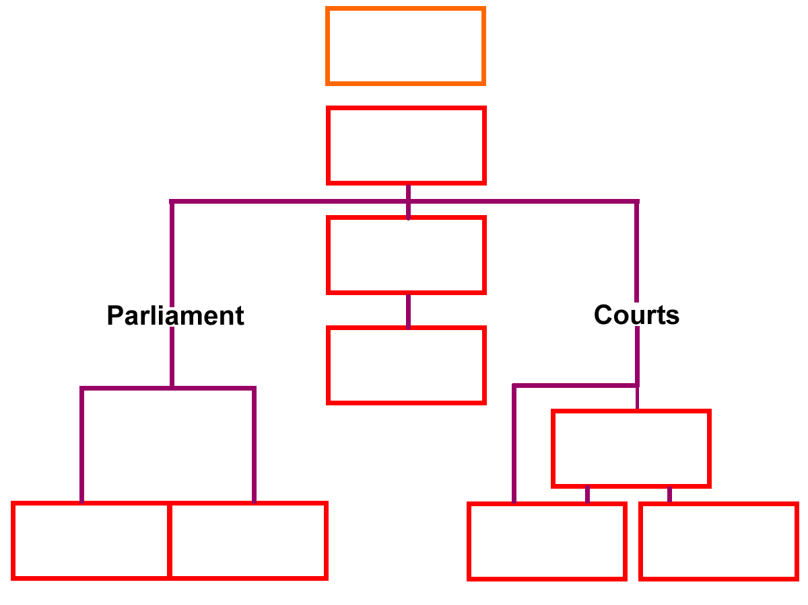Fill in the boxes and with the corresponding information.

**Canada's Government: The Three Branches Explained**

**The Legislative Branch: Where Laws Are Made**  
Think of Canada's **Parliament**[1] as the country's main discussion and **decision-making**[2] forum—a place where elected representatives (called **Members of Parliament**[3] (MPs)) gather to debate, discuss, and ultimately create the laws that govern the lives of Canadians. Whether it's establishing new rules, updating existing ones, or scrapping (repealing) outdated regulations, Parliament is where it all happens.

Parliament operates like a three-part team, consisting of the Governor General, the House of Commons, and the Senate. While Canada still recognizes a King or Queen as part of this structure, the Crown's role today is purely ceremonial. The monarch can offer advice to Parliament, but holds no real decision-making power in how Canada is actually run.

The **Governor General**[4] serves as the Crown's representative in Canada and handles several important ceremonial duties. When Parliament passes a **bill[5]**, the Governor General provides "**royal assent**"—essentially the official stamp that transforms a proposed law into an actual law. The Governor General also calls elections when the Prime Minister requests them and delivers the "**Speech from the Throne**," which outlines the government's plans and priorities for the country.

**The House of Commons: Where Democracy Happens**  
The heart of Canadian democracy beats in the House of Commons, often called the "lower house." To become a Member of Parliament candidates must win their local area—called a **riding**—in a federal election. This means every MP represents real people from a specific community, carrying their voices and concerns to Ottawa.

The House of Commons wields significant power in Canada's democracy. Not only do MPs create, modify, and eliminate laws, but they also keep a watchful eye on the executive branch to ensure the government operates properly. Since MPs are directly elected by Canadian voters, they possess the ultimate democratic weapon: the power to remove a prime minister or even topple an entire government through a vote of **non-confidence**.[6] Importantly, only the House of Commons holds the power to create laws involving government spending. This ensures that decisions about how taxpayer money is used remain in the hands of directly elected representatives.

**The Senate: The Chamber of Second Thought**  
While the House of Commons represents the will of the people, the **Senate**—known as the "upper house"—serves a different but equally important function. Unlike MPs, senators aren't elected by voters. Instead, they're appointed by the Prime Minister and can serve until age 75.

The Senate's role revolves around three key responsibilities: first, senators bring long-term experience and historical perspective to lawmaking. Since many serve for years or even decades, they offer institutional memory and wisdom that can improve legislation.

# Snapshot in History

In 2016 the House of Commons voted in favor of passing *Bill C-14* (assisted dying legislation) into law. The proposed bill was sent to the Senate to be approved (because in Canada both the lower and upper houses must approve of a bill in identical form for it to become law. After the House of Commons passed the bill legalizing medical assistance in dying, the Senate took extra time to carefully study the complex ethical, legal, and medical issues involved. Senators proposed amendments (changes) to the bill to strengthen safeguards, clarify eligibility criteria, and protect vulnerable populations before the bill became law. Specifically, the Senate's biggest concern was that Canada's healthcare system wasn't ready to safely provide MAiD (medical assistance in dying) for mental illness cases. This mattered because implementing the policy without proper preparation could put vulnerable people at risk. This careful scrutiny helped improve the legislation by addressing concerns the House had missed, showing the Senate's role in thoughtful, reflective review rather than rushed approval.

Second, the Senate acts as a quality control mechanism for laws. Every bill must pass both the House of Commons and the Senate in exactly identical form to become law. If senators reject a bill, it either dies completely or returns to the House of Commons for revision.

Third, the Senate provides crucial balance in Canada's democracy. Rather than creating new laws themselves, senators offer a "**second look**" at legislation, helping ensure the House of Commons doesn't rush through poorly conceived laws. This system encourages thoughtful, well-crafted legislation. Like the House of Commons, the Senate cannot create laws about government spending—this power remains exclusively with elected representatives.

With that said, the Senate has its critics: many Canadians have argued the Senate is obsolete because its members are appointed (not elected) and that senators have typically been appointed as a reward for loyalty to this or that political party, e.g. when the Conservatives are in power they elect conservative-friendly senators and when the Liberals are in power they elect liberal-friendly ones. Also, some critics think it's unnecessary to duplicate the work of the House of Commons; and finally, provinces with higher populations are under-represented compared to provinces with smaller populations, e.g. Quebec has 24 senators (1:376,000 people per) and Saskatchewan has six (1:205,000 per senator giving it higher representation). The major hurdle to reforming or even abolishing the Senate is it would require a change to Canada's *Constitution*; and changes to the *Constitution* are not easy, e.g. seven of ten of Canada's provincial legislatures would have to approve of the change and these seven provinces would have to represent at least 50% of Canada's overall population.

For this reason **Prime Minister Justin Trudeau** attempted a less radical approach to reform in 2014. He disbanded the Liberal Party in the Senate forcing these senators to sit as "**independents[7]**." Trudeau argued that Senators, like judges, shouldn't be affiliated with any particular political party because they serve *all* Canadians and *all* regions. He oversaw the creation of the Independent Advisory Board for Senate Appointments; this is a non-party body tasked with recommending senators based on merit and diversity (not party loyalty). However, the Conservative Party did not disband its party presence in the Senate, e.g. as of 2025 there were still 14 Conservative senators. Nonetheless, of the total 105 senators, 83 senators are currently not affiliated with any particular party.

**The Executive Branch: Enforcing the Law**  
While Parliament makes the laws, someone needs to actually run the country and enforce those laws in practice. That's where the executive branch comes in. This branch handles Canada's day-to-day operations, protects the ***Constitution***[8] and ***Charter of Rights and Freedoms****[9]*, and makes the countless decisions required to keep a modern nation functioning.

However, the executive branch can't act alone. Even though they run the government, they still need approval from a majority of MPs in the House of Commons to pass new laws—ensuring democratic oversight remains strong.

The executive branch's structure follows a simple principle: the political party that wins the most seats in a federal election gets to form the government. The winning party's leader automatically becomes Prime Minister, who then selects other MPs from their party to join the Cabinet—essentially the PM's team of senior ministers.

**The Prime Minister**  
The **Prime Minister (PM)** stands at the center of Canada's government as the leader of whichever political party wins the most seats in an election. While technically the PM doesn't have to be an elected MP, tradition dictates they always are.

The Prime Minister's responsibilities span the entire scope of government operations. They appoint Cabinet ministers from their party, recommend candidates for Governor General, and historically at least, appoint senators. The PM also sets the government's overall policies and direction, participates in House of Commons debates, and can introduce new bills for Parliament to consider.

**The Cabinet: The Prime Minister's Team**  
The Cabinet functions as the Prime Minister's team of senior ministers, with each minister responsible for running a different government department—whether that's Agriculture, Defence, Health, or any other area of federal responsibility. Every Cabinet minister must also be an elected Member of Parliament, ensuring they remain accountable to voters.

Officially, the Cabinet derives its authority from both the Crown and Canada's *Constitution*. Unlike the United States, which overthrew the monarchy during the American Revolution, Canada chose to maintain the monarch as head of state. However, this role is purely symbolic—the King or Queen wields no real power in Canadian politics.

The actual power in Canada flows from the *Constitution Act* of 1982, with that power exercised by either MPs or judges depending on the situation. Cabinet ministers must answer to the House of Commons for all their conduct, decisions, and actions, ensuring democratic accountability remains strong.

**The Judicial Branch: Interpreting and Upholding the Law**  
Courts serve as democracy's referees, ensuring that everyone—from ordinary citizens to the Prime Minister—follows the law equally. The judicial branch interprets laws and guarantees that no person, regardless of their power or position, stands above the law. This principle of equal accountability forms one of democracy's cornerstones.

Canadian courts operate independently from both Parliament and the Prime Minister. This independence isn't accidental—it ensures courts remain fair and unbiased when making decisions, free from political pressure or influence.

**Canada's Three-Level Court System**  
Canada's court system operates like a pyramid with three distinct levels, each handling different types of cases and legal issues.

At the top sits the **Supreme Court of Canada**, the country's highest court whose decisions are absolutely final—no other court can overturn their rulings. The Supreme Court's primary responsibility involves interpreting the Constitution and the Charter of Rights and Freedoms, making decisions that affect all Canadians' fundamental rights and freedoms.

**Federal Courts** occupy the middle level, handling cases involving federal laws and government operations. These courts deal with immigration cases, disputes between provinces, and conflicts between citizens and federal agencies like Canada Post or Revenue Canada. The Federal Court splits into two divisions: the **Trial Division**, which makes original decisions on cases, and the **Appeal Division**, which reviews those decisions when someone disagrees with the trial result.

**Provincial Courts** form the foundation of Canada's justice system, handling the everyday legal cases that most directly affect regular Canadians. These courts process criminal charges articulated in Canada's ***Criminal Code****[10]* like theft, assault, and impaired driving, along with traffic violations. The courts, through **civil law**,[11] also render decisions on family matters such as divorce and custody disputes, and small claims involving disputes under $25,000. Some provinces also maintain **municipal courts** specifically for local bylaw violations like parking tickets and noise complaints. This three-level structure ensures that every legal issue, from a simple parking ticket to complex constitutional questions, receives appropriate attention at the right level of Canada's justice system.

**Governing Canada**  
Canada subscribes to a system of **responsible government**[12] and **constitutional monarchy**,[13] combined with the features of a federation and **parliamentary democracy**.[14]Canada is a **federation**.[15] This means the work of governing Canada is shared by both two levels of government—federal and provincial/territorial. There are at least two advantages to governing through federalism: the first is it allows a national government based in Ottawa to meet most of the needs of most Canadians; and secondly, needs not met directly by the national government are supported through the work of provincial and territorial governments, e.g. serving the special interests and characteristics of the country’s various regions and cultural/linguistic communities.

The first four provinces who joined 1867 to form the Dominion of Canada are Ontario, Quebec, Nova Scotia and New Brunswick. In the decades following, six more provinces and three territories entered **Confederation**.[16]

The first four provinces came together and signed the ***British North America Act*** (1867). The Act gives the **Federal Government** (based in Ottawa) responsibility for things like fighting wars, negotiating international trade agreements, upholding the *Criminal Code*, and overseeing national policies related to taxation, interest rates, and monetary policy.**Provincial governments** like Saskatchewan's have jurisdiction over matters of local interest like primary and secondary education, health and social services, property and civil rights, and provincial and municipal. Schools are generally run by school boards or commissions elected under provincial education acts.

Some responsibilities are shared by both levels of government, e.g. transportation and highways, movement across provincial and international borders, and natural resources management. If federal and provincial laws in any of these areas conflict, federal law prevails (because it is the higher authority).

The **territorial governments** (Yukon Territory, Northwest Territories, and Nunavut) have more or less the same responsibilities as the provinces; however, territories do not have any control over land and natural resources. The powers territories possess are not actually written down in the Constitution. Instead, territorial powers are granted directly by the Federal Government (who can change them whenever it's deemed necessary).

A basic principle of the *British North America Act* (also known as the *Constitution Act*) is that any power not specifically assigned to provincial legislatures automatically belongs to the Parliament of Canada. Such powers are called ***residual powers*** and are based on a legal interpretation of the **P.O.G.G.** **clause** (“Peace, Order, and Good Government”) allowing the national government to make any laws in areas not expressly reserved for the provinces. This means social issues following the appearance of new technologies, like the Internet, end up being addressed by the national government as opposed to Saskatchewan's provincial legislature. In interpreting the law, the courts have generally followed the principle that if the power appears to be local, then it will be assigned to the provinces and territories, and if it appears to be national, then the power goes to the Federal Government, or to both levels if the power is both national and local (for example, the environment).

# Snapshot in History

In 2007 Quebec implemented Canada's first carbon tax and British Columbia followed suit a year later. The idea of a national carbon tax was discussed as early as 2015, but some provinces—most notably Alberta, Saskatchewan, Manitoba, Ontario and New Brunswick—opposed the idea. Alberta's corporations and government were concerned the tax would hurt the province's economy. Nonetheless, in 2019 the Liberal government announced a national carbon tax effective across the country under the *Greenhouse Gas Pollution Pricing Act* (2018). The Alberta government launched a challenge to the carbon tax at Alberta Court of Appeal in February of 2020. The Alberta Court concluded Ottawa's carbon tax was unconstitutional because it was an intrusion into provincial powers. The case was eventually sent to the Supreme Court who in 2021 upheld the federal government's power to impose a national carbon pricing system as part of its "peace, order, and good government powers" to address climate change, a matter of national concern.

**Municipalities** are formed to handle the affairs of cities, counties, towns, villages, districts and metropolitan regions. They are set up by provincial legislatures and have only such powers as the provinces give them. They provide citizens with services such as water and sewer systems, garbage disposal, roads, building codes, parks and libraries and have authority over property tax.

**Elections**Canadians play an active role in how and by whom Canada is governed. Citizens elect members of Parliament to the **House of Commons** (the Lower House of Canada's legislative branch) and to provincial and territorial legislatures to make decisions and enact laws on the behalf of Canadians. Regular elections ensure that Canadians continue to be represented by candidates of their choice. The *Constitution* sets the maximum term of a Parliament at five years. However, the government in power may call an earlier election at any time. To do so, the Prime Minister must ask the Governor General to dissolve the House and call an election.

Representation in legislatures is based on geographical divisions known as **electoral districts**, constituencies or ridings. Each riding elects one member to the legislature. Federally, riding boundaries are established every ten years by independent commissions, taking into account population and social and economic links. Elections are conducted riding by riding, with the winner being the candidate with the greatest number of votes. It is not necessary to have a majority of votes to win. Most candidates running in federal, provincial or Yukon elections belong to a political party. In the case of both the **Northwest Territories** and **Nunavut**, no political parties exist (all candidates run as independents). As of 2025 Canada has a total of 343 ridings (each riding contains approximately 121,000 Canadians). Canada's population in 2025 was 41.5 million.

**Political parties** are a group of people who establish a constitution outlining their common vision, elect a leader and other officers, and support candidates for election to the House of Commons federally, or to the legislature provincially or in the Yukon. Although for the first half century of its existence, Canada had only two political parties, Conservative and Liberal, since the 1920s, there have been representatives from at least three to five political parties sitting in Parliament at any given time. To be registered for a federal election, a political party is required to have had at least 12 members in the previous Parliament, or must nominate a minimum of 50 candidates 21 days prior to the election. Provincially and in the Yukon, the process is much more complex, ranging from single-party dominant systems to competitive three-party systems across the country (candidates in territorial elections in the Northwest Territories and Nunavut are not members of political parties).

All Canadian citizens at least 18 years of age on Election Day are eligible to vote, with very few exceptions. To ensure impartiality, the officials responsible for election administration—the Chief Electoral Officer and the Assistant Chief Elector Officer—may not vote in a federal election. Some residency restrictions apply for voters outside the country.

1. **Parliament**: is the legislative branch of government in Canada responsible for making laws, approving taxes, and holding government (the executive branch) accountable/responsible. Parliament meets in Ottawa, Ontario.
2. **Decision-making**: refers to the ability of elected officials and institutions to make laws, set policies, and take actions on behalf of the people. This power is shared and limited by rules like constitutions and it's based on the principle that citizens have a voice—usually through voting and representation—in how decisions are made.
3. **Members of Parliament (MPs)**: are elected representatives who sit in the House of Commons to represent a geographical area called a riding. The average number of people each individual MP represents is 108,000.
4. **Governor General**: the monarch's representative in Canada. This position is largely ceremonial; however, they have some important responsibilities, e.g. give "Royal Assent" to laws passed by Parliament; appoint the Prime Minister; dissolve Parliament and call elections (on the advice of the Prime Minister); and representing Canada at official events.
5. **Bill**: a bill is a proposed law that is typically first introduced and debated in the House of Commons.
6. **Non-confidence Vote**: a formal vote in Parliament that is used to remove the government in power, e.g. if a majority of MPs vote "no" then the government is defeated and the Governor General dissolves Parliament and calls an election. Non-confidence votes are one of the tools used by the House of Commons to keep the executive branch accountable to the People. This happened in 1979 when Prime Minister Joe Clark lost power after a majority of MPs voted against his government's plans for a budget. Clark's government lasted only seven months—a reminder that in Canada's democracy, even prime minister must maintain the support of elected representatives.
7. **Independents**: politicians—such as senators or MPs—who do not belong to any official political party. They are not bound by a party platform or required to follow party discipline (meaning they can vote freely based on their own judgement, constituent's interests, or conscience rather than a party line).
8. ***Constitution***: a set of fundamental laws and principles outlining how a country is governed; it defines the structure and powers of government, the rights and responsibilities of citizens, and the rules by which laws are made and enforced.
9. **Charter of Rights and Freedoms**: is part of Canada's *Constitution* that guarantees things like freedom of expression, freedom of religion, the right to vote, and equality rights; and, more importantly, the *Charter* limits what governments can do and ensures that laws and policies respect individual freedoms and democratic principles.
10. ***Criminal Code***: a federal law in Canada listing and defining most of the crimes that can be committed in the country, along with punishments for those crimes. The *Criminal Code* applies across all provinces and territories and is enforced by police, prosecutors, and the courts to maintain law and order.
11. **Civil Law**: criminal law deals with crimes against society and aims to punish offenders, while civil law resolves disputes between individuals or groups (often through compensation (money)).
12. **Responsible government** refers to a government that is “responsible” to the people. In practical terms, this means the political party that has formed government is dependent on the continued support of the elected assembly (House of Commons) rather than on the good-will of the Monarch.
13. A **constitutional monarchy** is a form of national government in which the power of the Monarch is restrained by a parliament, by law, or by custom. Constitutional monarchs do not rule *absolutely* but are *limited* by a constitution.
14. A **parliamentary democracy** is a form of government in which the party (or a coalition of parties) with the greatest representation in the legislature forms the government, its leader becoming either prime minister or chancellor.
15. A **federation** is an organization or group (like provinces and territories) that have some degree of control over their own regional affairs while ultimate authority resides in a central government.
16. **Confederation** is literally the name for the process Canada’s provinces joined together becoming confederated (joining with one another).